Name : Himesh pathai

Div : D10A

Roll No. : 35

EXPERIMENT NO. 1

**Aim** : To understand the benefits of Cloud Infrastructure and Setup AWS Cloud9 IDE, Launch AWS Cloud9 IDE and Perform Collaboration Demonstration.

**EC2 Instance Creation and static site hosting**

1. Login to your AWS account

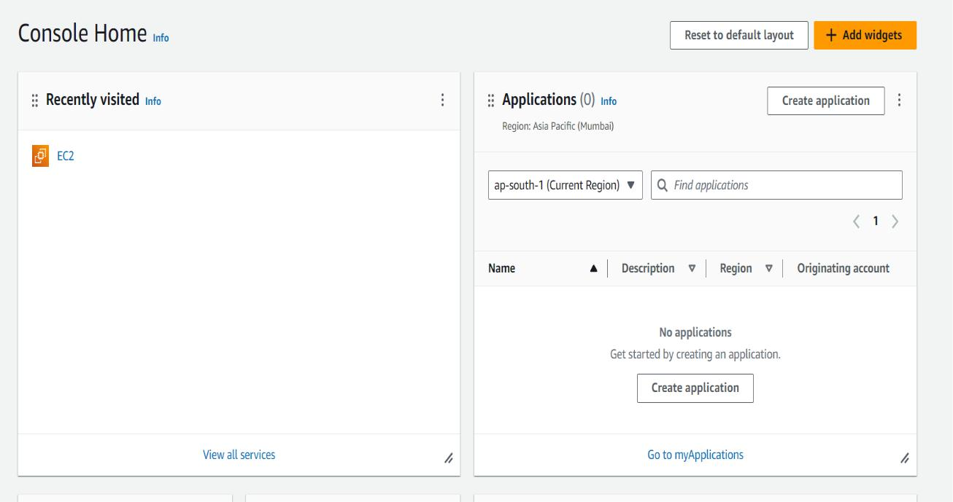

2. Click on EC2 and then create an instance by clicking on instances

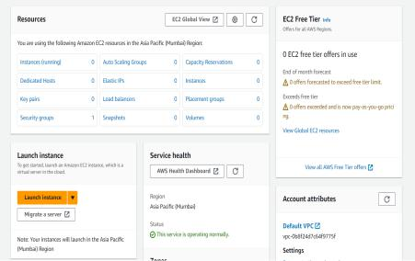

3. After an instance is created wait for it to come to Running state

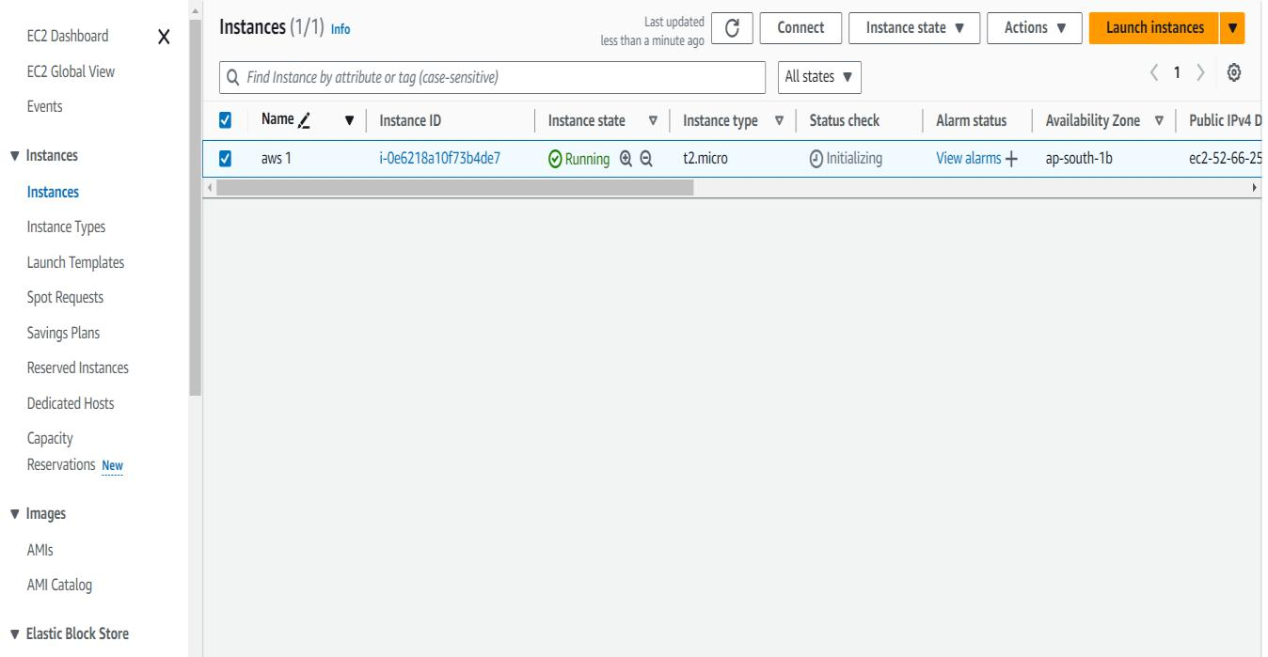

4. After doing that you will see this UI

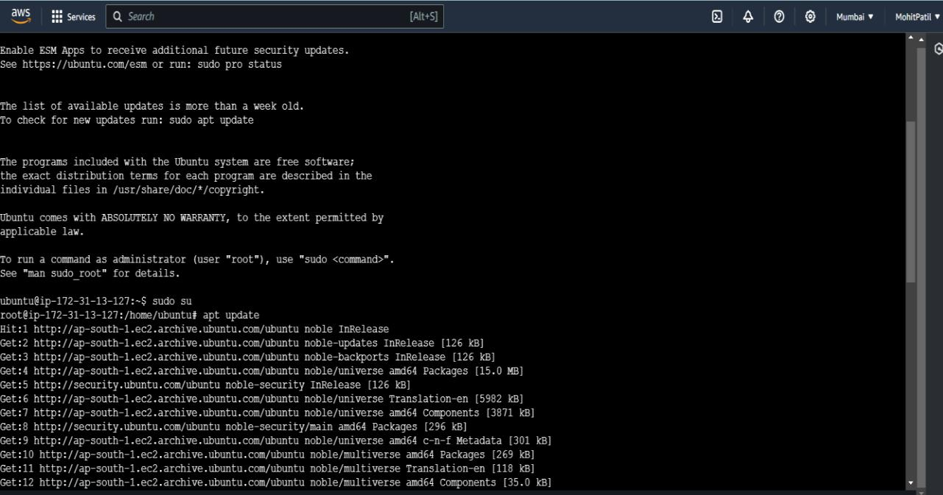

5. Follow these steps and then run these commands

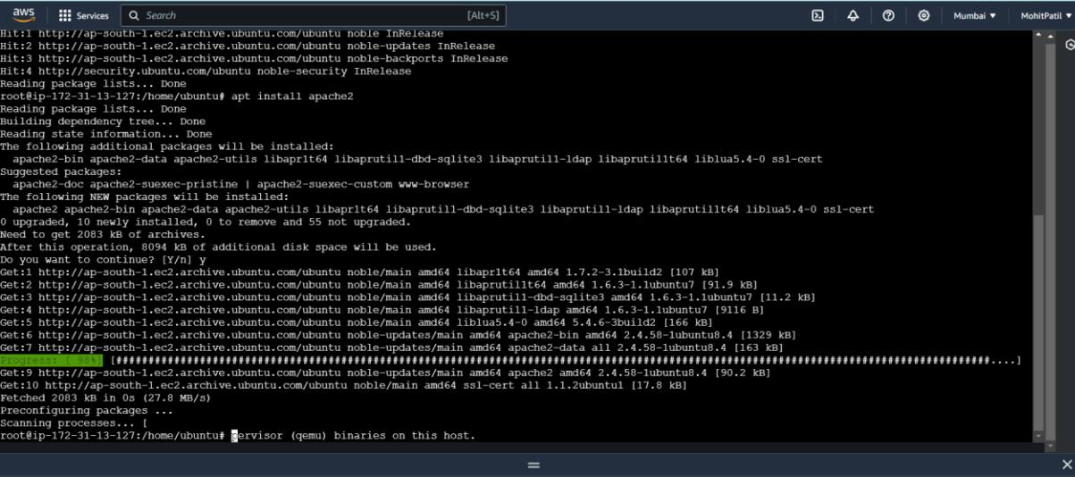

1. After that the ip-address which was given while running the instance, copy that and paste that on chrome, make sure that it is http and not https

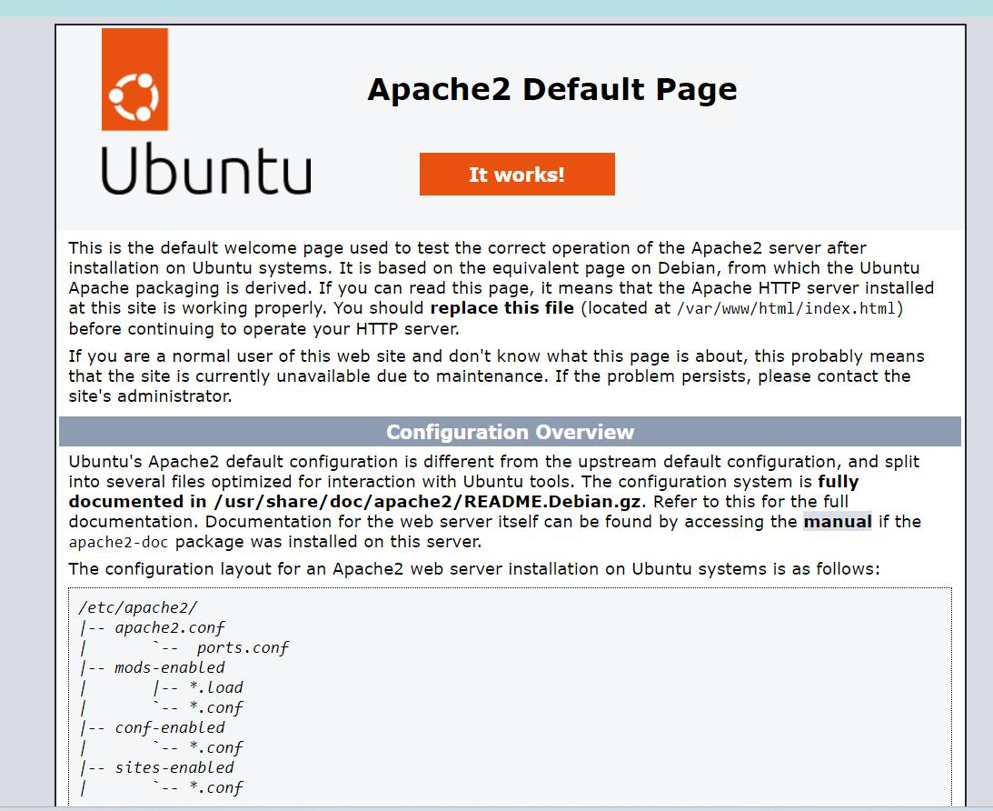

7. Create a file using vi command and save it using : wq

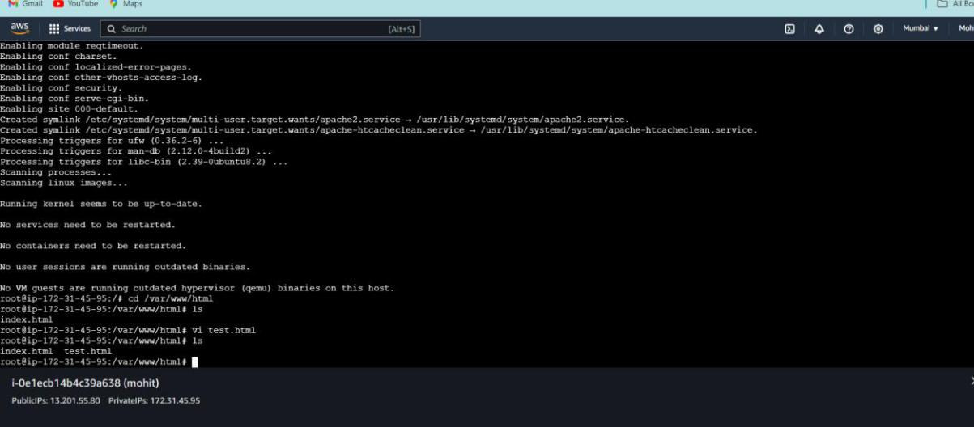

1. After saving that file go that page where ubuntu is listed and then on the link add “/your_file_name.html” and then whatever you saved on that file will be displayed

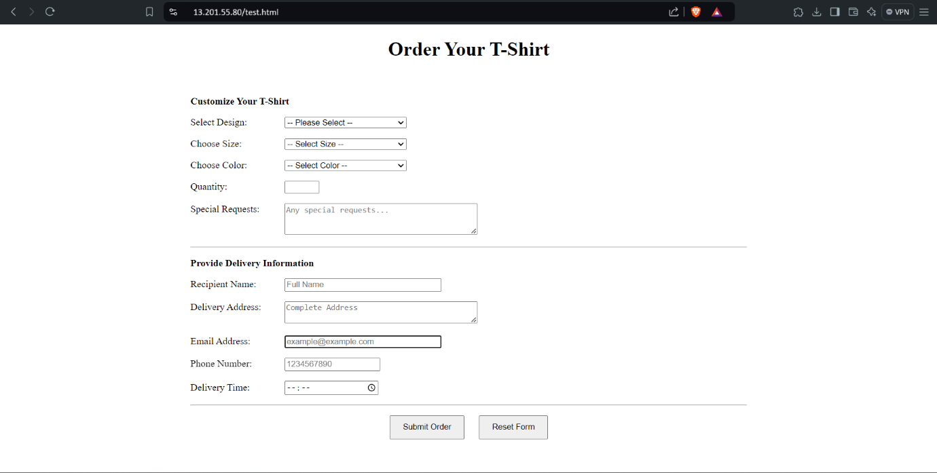

**Static Hosting using S3 bucket**

Step1: Create bucket

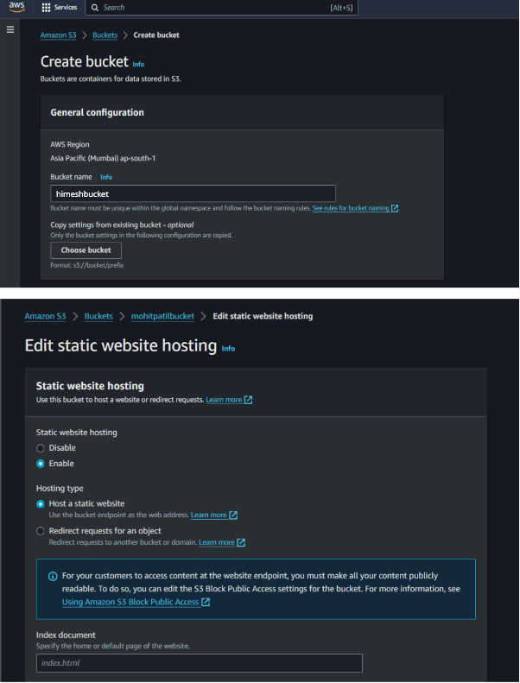

Step 2: Add resources

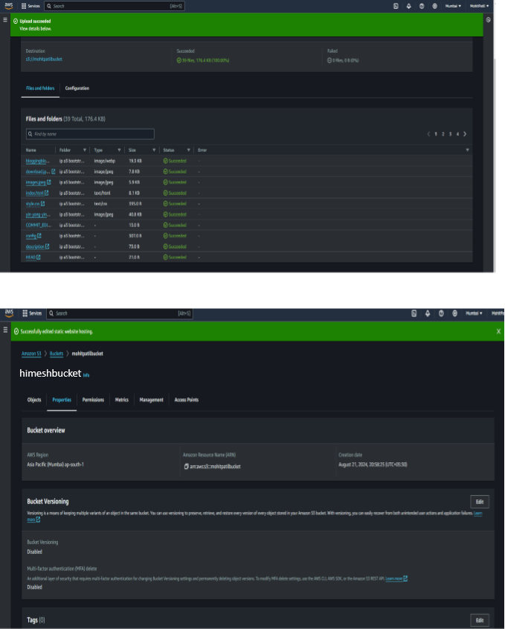

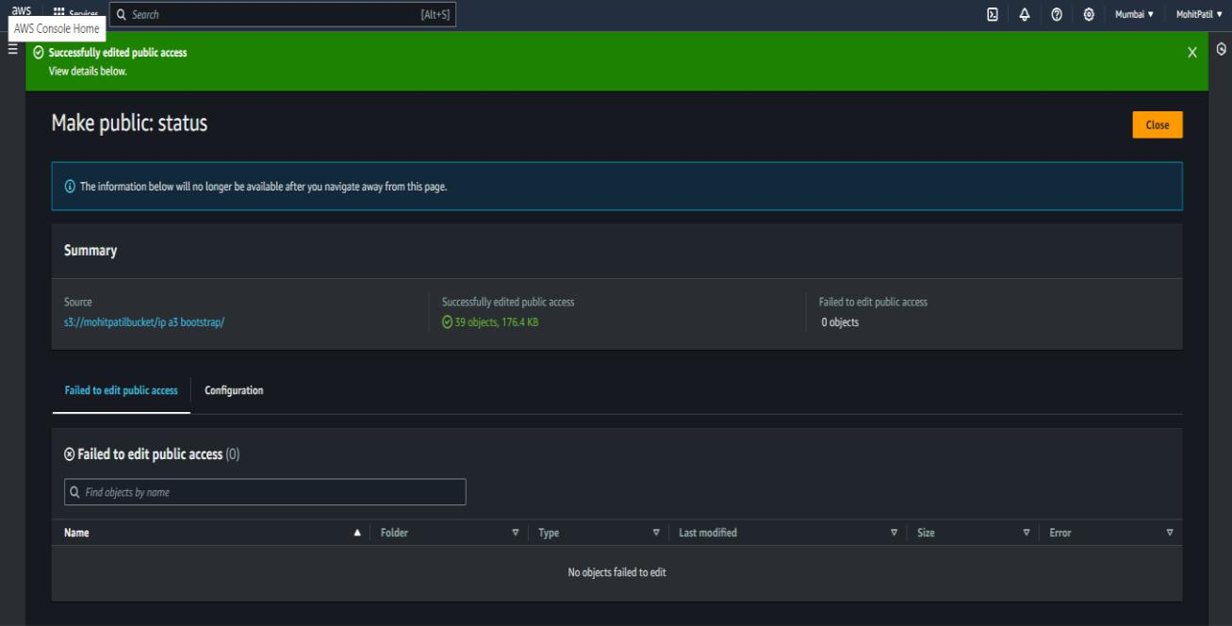

Step 3 : visit hosted website

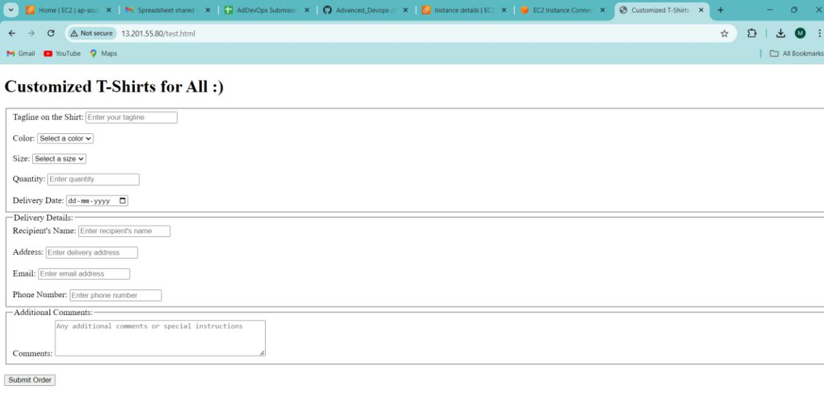

**EC2 Dynamic Site Hosting**

Step 1 : Open Console and clone the github repository

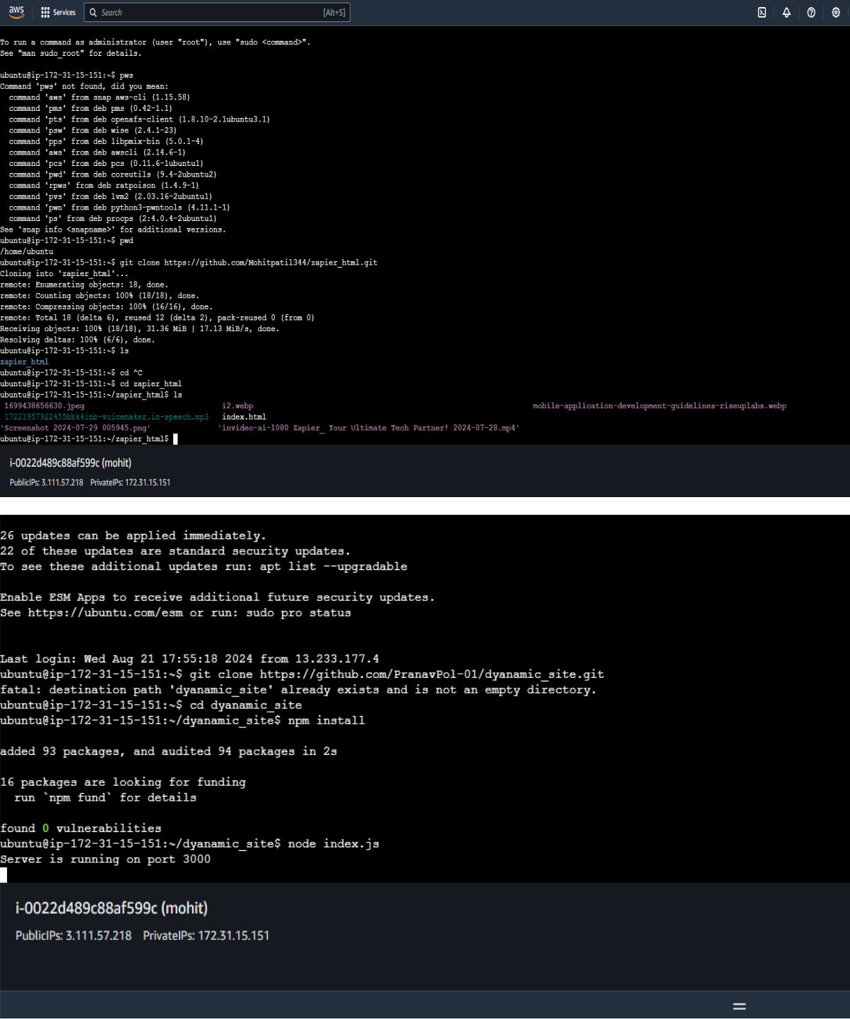

Step 2 : Install necessary Packages and run website on port 3000

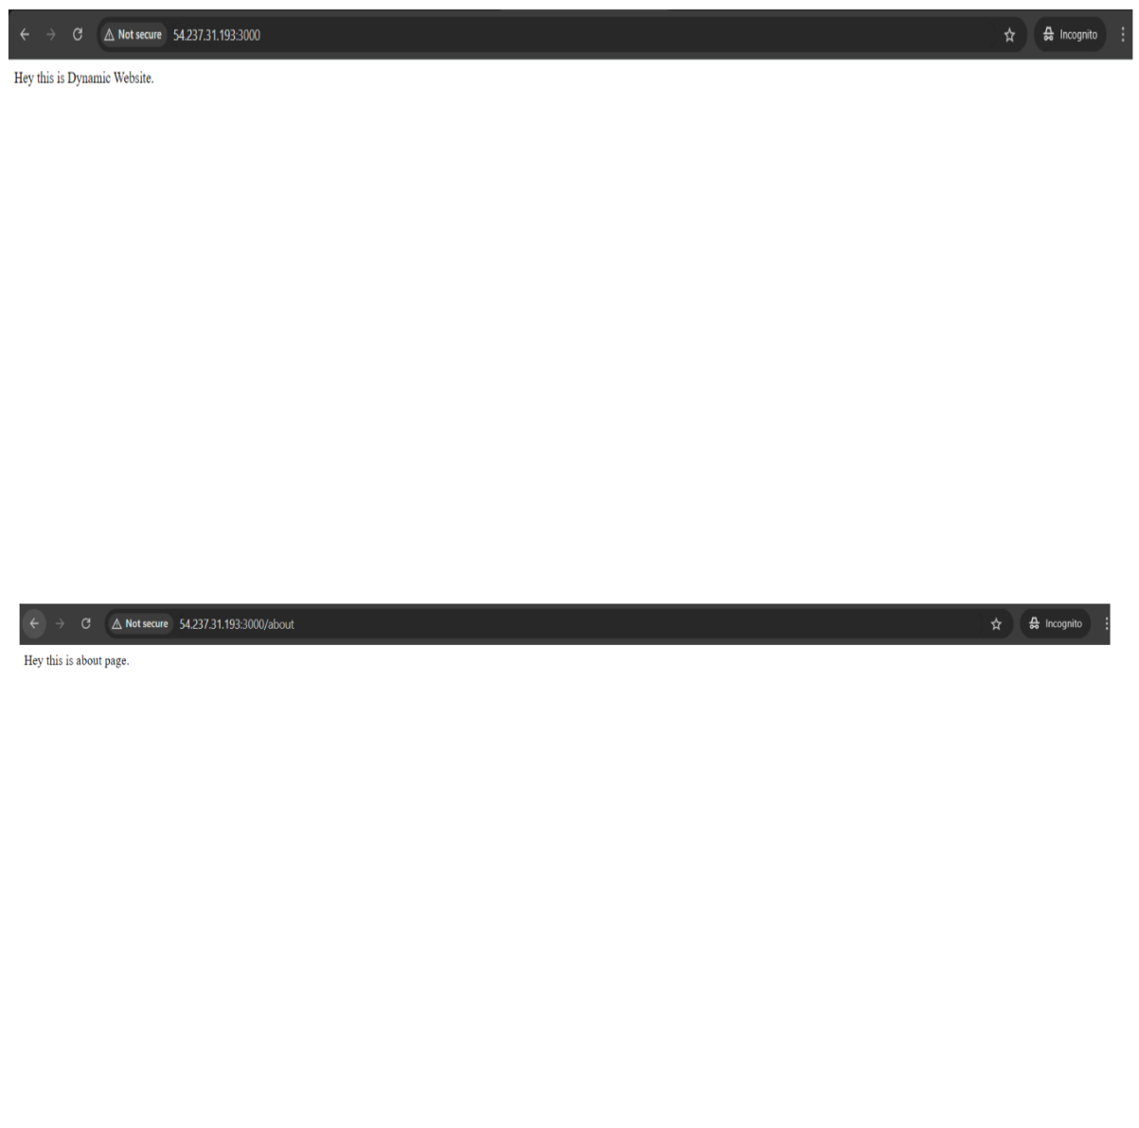

**Cloud 9 IDE Site Hosting**